Alt + shift + W : wrap selection an HTML Tag

ul + p {

} bezieht sich nur auf den Paragraphen der NACH der ul kommt (wenn p innerhalb ul befindet wird er nicht betroffen) und auch nur wenn zwischen dem paragraphen und der liste kein sonstiges element steht

Div:nth-child(3) ist nicht das gleiche wie div:nth-of-type(3)

Default font-size is 16px for most browsers

Em is a dynamic unit. 1em is equal to the font size defined in a parent element.

If fontsize was set to 16px, 1.5em would be 24px.

Font-weight: bold;

Font-weight: 100-800; (if supported by font)

Line-height bestimmt den Abstand zwischen Zeilen und ist abhängig von der Fontgrösse.

<link href="https://fonts.googleapis.com/css?family=Dosis:400,700" rel="stylesheet">

font-family: "Dosis", sans-serif;

font-weight: 700;

Box model:

The box model has 4 different aspects that we can manipulate:

1. Content
2. Padding
3. Border
4. margin

padding is not added to the total box width!$

How to align block elements in the same line next to each other:

Float: left

The first element that should float needs to have the property clear:both

Between most block elements there is a default whitespace, to get rid of that one can use float.

When we wrap images in a div and want to center the div on the page, we cannot set the side margins of the div to auto, because the div will automatically fill the whole horizontal space because it’s a block element, so giving it an auto margin will still cause the the div to be 100% of the screenwidth.

To counter that, we need to set div display: inline-block. This will make the div’s size fit exactly to it’s content. If the content is 70% of the screen’s width, the div will also be 70% of the screen and ~~margin auto will cause it to have 15% of the screen as margin left and right.~~ Not working need to use text-align:centers

Responsive screen width:

Setting a max-width:

Body {

Max-width: 700px;

Width: 70%;}

This makes the body 700px at max, and when the screen gets smaller and 80% are less than 700px, the body will shrink accordingly.

Media queries:

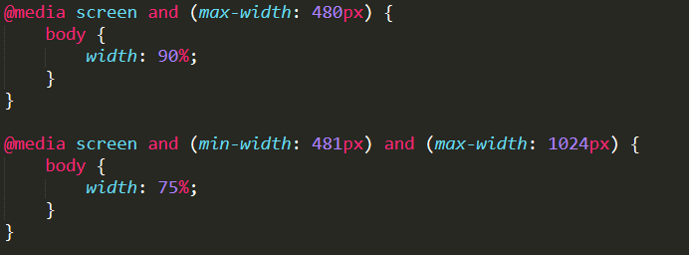

The em font-size is proportional to the font-size of the parent element, so 2.0em would be twice the size of the parent element’s font size. The unit rem however is always proportional to the root font-size.

The content property in CSS is used with the pseudo elements :before and :after and allows us to insert content somewhere. This method is used by bootstrap to insert glyphicons.

For example if we want to insert an icon before our h1 header:

<h1>

<span class="glyphicons-scissors"></span>

beat coiffure

</h1>

CSS:  
.glyphicons-scissors:before {

content: url(scissors.png);

}

For more information see: <https://css-tricks.com/almanac/properties/c/content/>